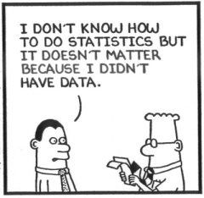

Name ________________________________________

Math 3 Unit 9: Statistics

May 21  - Observational study vs experiment  - Sampling techniques  HW: worksheet 9.1 and 9.1R  9.1  9.1R | May 22  - Population, parameter, sample, and statistic  HW: worksheet 9.2 and 9.2R  9.2  9.2R | May 23  - Bias  - Margin of error  HW: worksheet 9.3 and 9.3R  9.3  9.3R | May 24  - Simulations  - Review for quest  HW: finish review | May 25  - QUEST!! (too big to be a quiz, but too small to be a test)

9.1 - Sampling Techniques
For each situation, identify the sampling technique used (simple random, cluster, stratified, convenience, voluntary response, or systematic. .

1. Every fifth person boarding a plane is searched thoroughly.

2. At a local community College, five math classes are randomly selected out of 20 and all of the students from each class are interviewed.

3. A researcher randomly selects and interviews fifty male and fifty female teachers.

4. A researcher for an airline interviews all of the passengers on five randomly selected flights.

5. Based on 12,500 responses from 42,000 surveys sent to its alumni, a major university estimated that the annual salary of its alumni was 92,500.

6. A community college student interviews the first 100 students to enter the building to determine the percentage of students that own a car.

7. A market researcher randomly selects 200 drivers under the age of 35 and 100 drivers over the age of 35.

8. All of the teachers from 85 randomly selected nation’s middle schools were interviewed.

9. To avoid working late, the quality control manager inspects the last 10 items produced that day.

10. The names of 70 contestants are written on 70 cards, The cards are placed in a bag, and three names are picked from the bag.

11. 32 sophomores, 35 juniors and 49 seniors are randomly selected from 230 sophomores, 280 juniors, 577 seniors at a certain high school.

12. To ensure customer satisfaction, every 35th phone call received by customer service will be monitored.

13. Calling randomly generated telephone numbers, a study asked 855 U.S. adults which medical conditions could be prevented by their diet.

14. A pregnancy study in Chicago, randomly selected 25 communities from the metropolitan area, then interviewed all pregnant women in these communities.

9.3R - Unit 5 and 6 Review

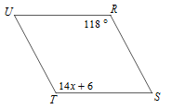
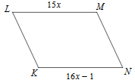
1. Solve for x. 2. Find the length of LM.

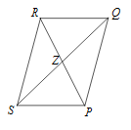
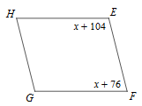
3. Given $RP=24$ and $ZP=x+1$, solve for x. 4. Find the m∠F.

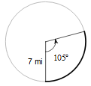
5. Determine the center and radius of: 6. Determine the arc length.
$(x+4)^{2}+(y+2)^{2}=4$

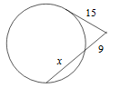
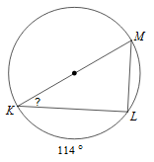
7. Solve for x. 8. Solve for the missing angle.

9.3 - Types of Bias
Identify the type of bias in each of the the different scenarios.

1. A political blog conducts an online poll to gauge the approval rating of a candidate for political office.

2. To investigate people’s preference for different brands of toothpaste, a polling firm selects a random sample of telephone numbers from the phonebooks of several large cities.

3. Students are asked by their teacher: “You haven’t ever cheated on a test, have you?”

4. To investigate the amount of energy drinks consumed by college freshmen, a student stands on a campus
sidewalk and interviews willing participants.

5. A mail survey asks people’s opinion on the preservation of wilderness areas. Only a small percentage of the surveys were completed and returned, and those mostly favored an increase in wilderness areas.

6. A survey designed by residents opposed to building a new mall in their neighborhood asks: “Do you support the building of the mall which will increase traffic and lower property values?”

Tell whether the question is potentially biased. If it is, rewrite it so that it is unbiased.

7. Don’t you agree that the school needs a new baseball field more than a new science lab?

8. The budget of the Wake County Public School System is short of funds. Should taxes be raised in order for this district to fund extra-curricular sports programs?

9. Don’t you agree that the voting age should be lowered to 16 because many 16-year-olds are responsible and informed?

10. Due to diminishing resources, should a law be made to require people to recycle?

9.1R - Unit 1 and 2 Review

1. Solve the system: $y=3x+2$ 2. Find the inverse of: $y=\frac{6x+3}{2}$
$2x+y= -8$

3. Given $f(x)=3x+1$ and $g(x)=2x-4$, find $(g∘f)(x).$ 4. Solve: $\left|5x-2\right|-6=2$

5. Solve: $\log_{4}(9x-4)=3$ 6. Solve: $6^{x+1}=5$

7. If $4,000 is invested at 5% interest compounded quarterly, how much money will there be in 18 years?

9.2 - Population and Parameter vs Sample and Statistic
Identify the population and the sample:

1. A survey of 1353 American households found that 18% of the households own computer.

population: ____________________________ sample: _________________________________

2. A recent survey of 2625 elementary school children found that 28% of the children could be classified obese.

population: ____________________________ sample: _________________________________

3. The average weight of every sixth person entering the mall within 3 hour period was 146 lb.

population: ____________________________ sample: _________________________________

Determine whether the numerical value is a parameter or a statistic:

4. A recent survey by the alumni of a major university indicated that the average salary of 10,000 of its 300,000 graduates was $125,000.

5. The average salary of all assembly-line employees at a certain car manufacturer is $33,000.

6. The average late fee for 360 credit card holders was found to be $56.75.

For the studies described, identify the population, sample, population parameters, and sample statistics:

7. In a USA Today Internet poll, readers responded voluntarily to the question “Do you consume at least one caffeinated beverage every day?”

population: ____________________________ sample: _________________________________

parameter: ____________________________ statistic: _________________________________

8. Astronomers typically determine the distance to galaxy (a galaxy is a huge collection of billions of stars) by measuring the distances to just a few stars within it and taking the mean (average) of these distance measurements.

population: ____________________________ sample: _________________________________

parameter: ____________________________ statistic: _________________________________

9.2R - Unit 3 and 4 Review

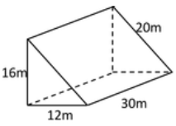
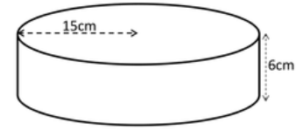
1. Determine the surface area. 2. Determine the volume.

3. Johnny is making paper cups in the shape of a cone. If the radius is 4 inches and the slant height is 7 inches, what is the surface area of each cup?

4. Divide: $\left(x^{3}+3x^{2}-8x-14\right)÷\left(x+2\right)$ 5. Determine zeroes and multiplicity of:
$f(x)=6(x-{4)}^{3}(x+3)$

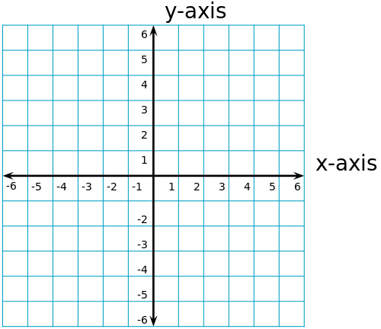
6. Find the requested information for the graph shown below:

zeroes:

increasing:

decreasing:

positive:

negative:

end behavior:

