8.8 - Applications of Trig Functions

1. The geese population in a certain area fluctuates periodically between a maximum of 600 geese and a minimum of 350 geese. This population cycle repeats every 5 years. Write a sine function to the model the geese population when time is measured in years.

2. The average monthly temperature in Greenville varies periodically with a maximum of 69°F and a minimum of 41°F. A complete cycle repeats every year. Write a cosine function to model the temperature in Greenville when time is measured in months.

3. The function $f(x)= -33cos\left(\frac{π}{6}x\right)+40$ models the height of a rider on a Ferris wheel, where x represents time in minutes. Determine the maximum and minimum height the rider reaches, and determine the amount of time it takes for the rider to complete a full revolution.

4. A Ferris wheel has a diameter of 92 m and makes a complete revolution every 8 minutes.. The wheel starts turning when a rider is at its lowest point, 9 m above the ground. Write a cosine function to model the rider’s height above the ground when time is measured in minutes.

5. The function $f(x)=1.3cos\left(4πx\right)+88.7$ models the altitude of the midday sun at Venus’s equator, where x represents time in years. Determine the maximum and minimum altitude the sun reaches, and determine the amount of time it takes for the sun to complete a full cycle.

6. When an appliance is plugged into an outlet, voltage fluctuates between positive and negative values. In Barbados, the voltage fluctuates between 163 volts and −163 volts with a frequency of 50 cycles per second. Write a sine function to model the voltage when time is measured in seconds.

Name ________________________________________

Math 3 Unit 8: Trigonometry

May 7  - Angles in degrees  HW: worksheet 8.1 | May 8  - Angles in radians  HW: worksheet 8.2 | May 9  - Right triangle trig  HW: worksheet 8.3 | May 10  - Unit circle  - Exact values of sine and cosine  HW: worksheet 8.4 | May 11  - QUIZ!!  - Exact values of all trig functions  HW: worksheet 8.5
May 14  - Graphs of sine and cosine  HW: worksheet 8.6 | May 15  - Equations of sine and cosine  HW: worksheet 8.7 | May 16  - QUIZ!!  - Applications of trig functions  HW: worksheet 8.8 | May 17  - Review for test  HW: finish review | May 18  - TEST!!!

8.1 - Angles and Their Measures in Degrees

Draw each angle in standard position.

1. $120^{o}$ 2. $-240^{o}$ 3. $550^{o}$ 4. $-270^{o}$

5. $300^{o}$ 6. $40^{o}$ 7. $-400^{o}$ 8. $-100^{o}$

Find one positive and one negative coterminal angle that corresponds to the given angle.

9. $55^{o}$ 10. $-40^{o}$ 11. $-16{00}^{o}$ 12. $415^{o}$

Determine an angle between $0^{o}$ and $360^{o}$ that is coterminal to the given angle.

13. $665^{o}$ 14. $-70^{o}$ 15. $-640^{o}$ 16. $1190^{o}$

8.7 - Equations of Sine and Cosine Worksheet

1. $y= -4cos4x+7$ 2. $y=6sin\frac{1}{3}x-4$
Amplitude:________ Amplitude:________
Period:________ Period:________
Frequency:________ Frequency:________
Vertical Shift:________ Vertical Shift:________

3. $y=sinx+2$ 4. $y=\frac{1}{2}cos\frac{4}{3}x$
Amplitude:________ Amplitude:________
Period:________ Period:________
Frequency:________ Frequency:________
Vertical Shift:________ Vertical Shift:________

5. $y= -2cos8x-4$ 6. $y= -sin3x+1$
Amplitude:________ Amplitude:________
Period:________ Period:________
Frequency:________ Frequency:________
Vertical Shift:________ Vertical Shift:________

7. Given an amplitude of 7, a period of 4𝜋, and a vertical shift down 3 units, write the equation of the sine function.

8. Given an amplitude of 3, a frequency of $\frac{1}{π}$, and a vertical shift up 7 units, write the equation of the cosine function.

9. Given an amplitude of 7456, a period of $\frac{π}{46}$, and a vertical shift up 81903 units, write the equation of the sine function.

8.6 - Graphs of Sine and Cosine
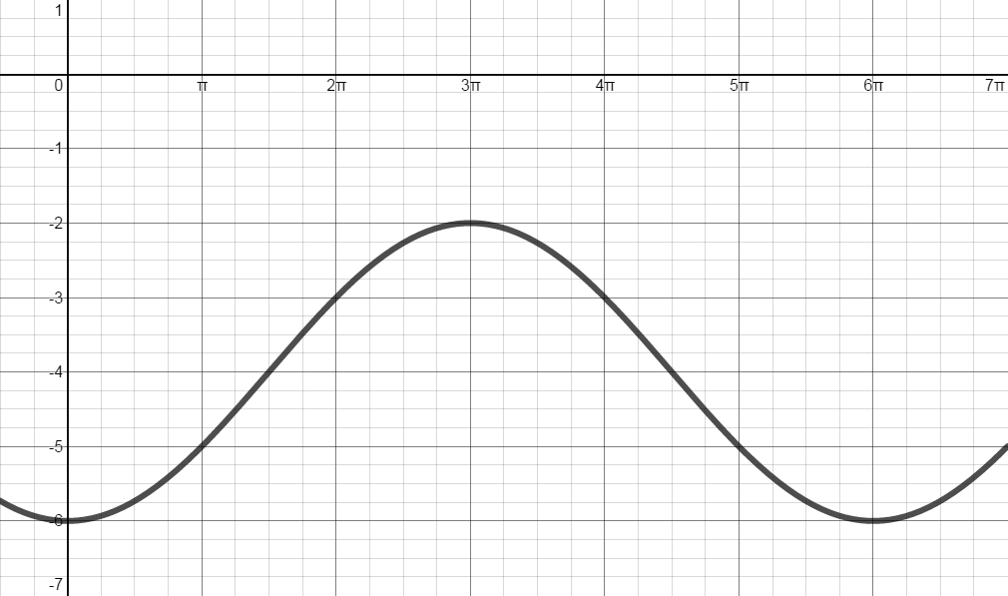
Determine the amplitude, period, frequency, vertical shift, and equation for each graph below.
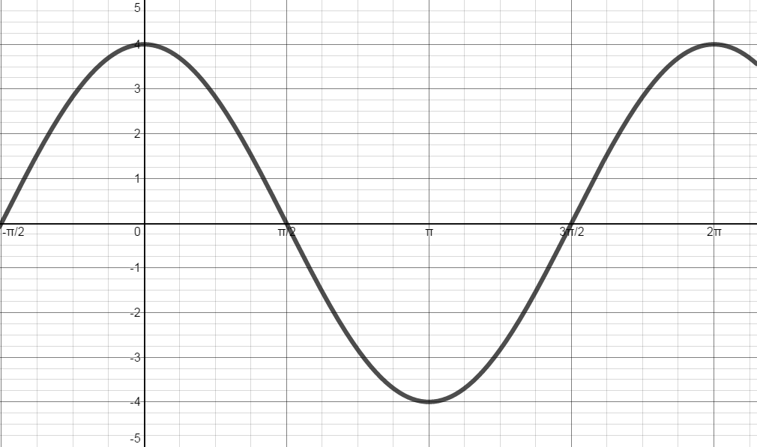
A B

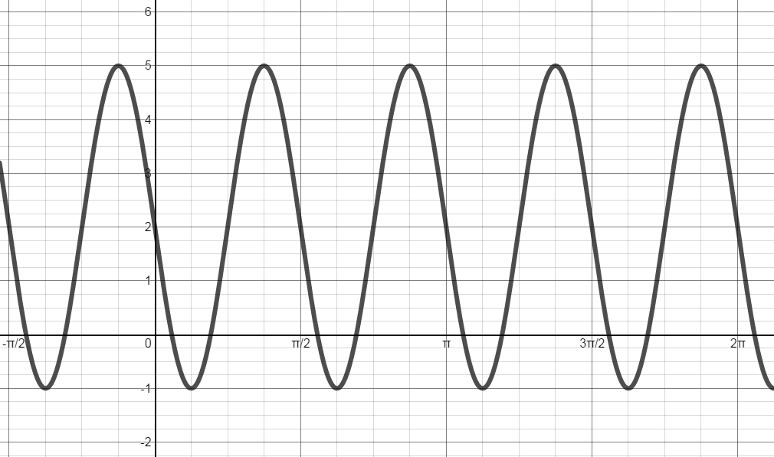
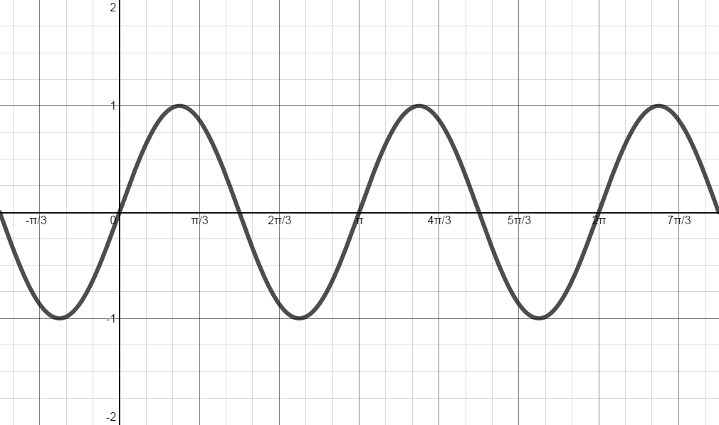
C D

 | Amplitude | Period | Frequency | Vertical Shift | Equation
A
B
C
D

8.2 - Angles and Their Measures in Radians

Convert angle in degrees to radians.

1. $18^{o}$ 2. $150^{o}$ 3. $330^{o}$ 4. $-270^{o}$

Convert each angle in radians to degrees.

5. $\frac{π}{9}$ 6. $\frac{3π}{4}$ 7. $\frac{11π}{6}$ 8. $-\frac{25π}{18}$

Draw each angle in standard position.

9. $\frac{5π}{6}$ 10. $-\frac{π}{4}$ 11. $\frac{10π}{3}$ 12. $-\frac{7π}{6}$

13. $π$ 14. $-\frac{2π}{3}$ 15. $-\frac{7π}{3}$ 16. $\frac{11π}{6}$

8.3 - Right Triangle Trig
Solve for the variable.
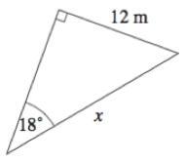
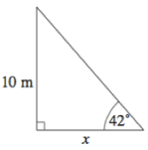
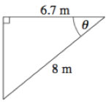
1. 2. 3.

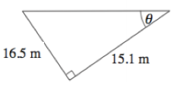
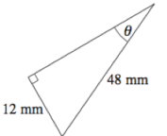
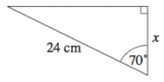
4. 5. 6.

7. The flagpole casts a shadow 40 feet long when the measurement of the angle of elevation to the sun is 31°. How tall is the flagpole?

8. A submarine dives at an angle of depression of 15°. It travels a horizontal distance of 1500 feet during the dive. What is the depth of the submarine after the dive?

9. Sally is standing a distance away from a skyscraper that is 780 feet tall. Marcie is between Sally and the skyscraper. The angle of elevation from Sally’s position to the top of the skyscraper is 42°. The angle of elevation from Marcie’s position to the top of the skyscraper is 71°. How far is Sally from Marcie?

Use the unit circle to determine the exact value of each trigonometric function.

1. $sin225^{o}$= 2. $cos150^{o}$=

3. $tan60^{o}$= 4. $sin\frac{π}{6}$=

5. $sec\frac{2π}{3}$= 6. $cot\frac{5π}{3}$=

7. $tan90^{o}$= 8. $cosπ$=

9. $csc\frac{3π}{4}$= 10. $sin2π$=

11. $cos-30^{o}$= 12. $sec585^{o}$=

13. $cot180^{o}$= 14. $sin\frac{π}{2}$=

15. $cos270^{o}$= 16. $sec\frac{7π}{6}$=

8.5 - Exact Values of Trig Functions
Complete the unit circle

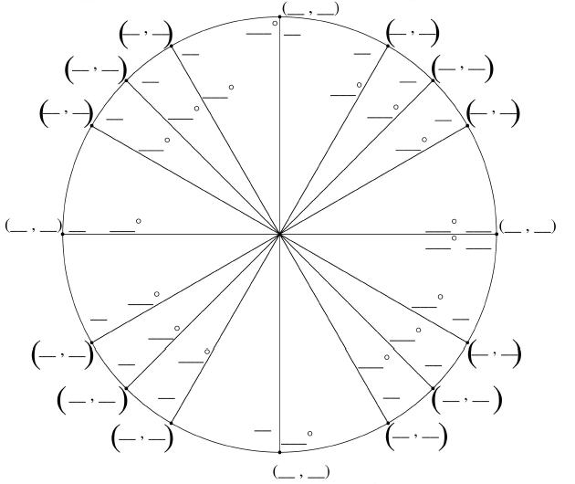

….said no teacher ever.

Turn the page to get to homework 8.4

(Like I would really give you a day without homework. Puh-lease)

8.4 - Exact Values of Sine and Cosine worksheet
Complete the unit circle.

Use the unit circle to determine the exact value of each trigonometric function.

1. $sin 45^{o}$= 2. $cos 0$=

3. $sin -210^{o}$= 4. $cos \frac{3π}{4}$=

5. $sin \frac{4π}{3}$= 6. $cos 240^{o}$=

7. $sin \frac{8π}{3}$= 8. $cos -90^{o}$=

9. $sin -855^{o}$= 10. $cos 570^{o}$=

11. $sin 270^{o}$= 12. $cos -\frac{π}{3}$=

13. $sin -3π$= 14. $cos \frac{11π}{6}$=

