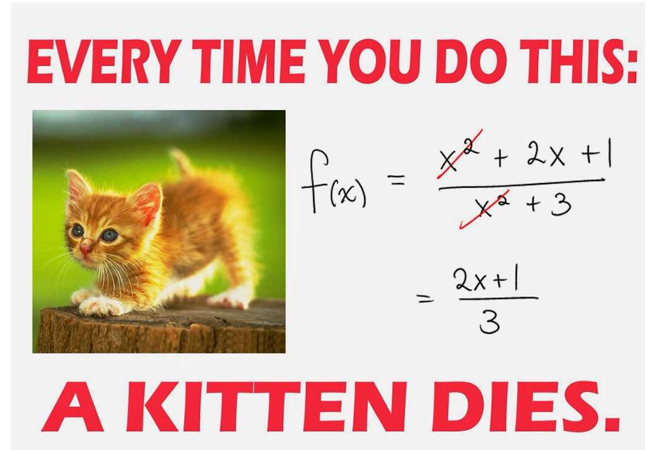
Name ___________________________________________

Math 3 Unit 7: Rationals

April 23  - Simplify rational expressions  HW: worksheet 7.1 | April 24  - Multiply and divide rational expressions  HW: worksheet 7.2 | April 25  - Add and subtract rational expressions with common denominators  HW: worksheet 7.3 | April 26  - Add and subtract rational expressions  HW: worksheet 7.4 | April 27  - QUIZ!!  - Solve rational equations  HW: worksheet 7.5
April 30  - Solve rational expressions  HW: worksheet 7.6 | May 1  - Asymptotes and holes of rational functions  HW: worksheet 7.7 | May 2  - Graph rational functions  HW: worksheet 7.8 | May 3  - Review for test  HW: finish review | May 4  - TEST!!!

7.8 - Graph Rational Functions
For each rational function, determine the holes, vertical asymptotes, domain, and horizontal asymptote. Then graph the rational function.

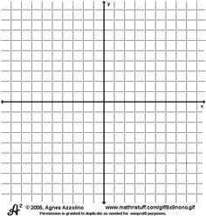
1. $f(x)=\frac{4}{x-5}$ 2. $f(x)=\frac{x-1}{x^{2}+3x-4}$

Holes: _______________________ Holes: _______________________
VA: _________________________ VA: _________________________
Domain: _____________________ Domain: _____________________
HA: _________________________ HA: _________________________
3. $f(x)=\frac{2}{x^{2}+3x-10}$ 4. $f(x)=\frac{x^{2}-4x+3}{x^{2}-x-6}$

Holes: _______________________ Holes: _______________________
VA: _________________________ VA: _________________________
Domain: _____________________ Domain: _____________________
HA: _________________________ HA: _________________________
7.1 - Simplifying Rational Expressions
Simplify each rational expression.

1. $\frac{27}{27x+18}$ 2. $\frac{v^{2}-7v-30}{v^{2}-5v-24}$ 3. $\frac{x^{2}+8x+12}{x^{2}+3x-18}$

4. $\frac{b^{2}+3b-28}{b^{2}-49}$ 5. $\frac{4n-4}{6n-20}$ 6. $\frac{2v^{2}+10v-48}{8v+64}$

7. $\frac{6v^{3}+42v^{2}}{2v^{2}+26v+84}$ 8. $\frac{x^{3}-x^{2}-42x}{2x^{2}-20x+42}$ 9. $\frac{9x^{2}+81x}{x^{3}+8x^{2}-9x}$

7.2 - Multiply and Divide Rational Expressions
Simplify each rational expression.

1. $\frac{k+9}{\left(k-8\right)\left(k-7\right)}⋅\frac{\left(k-7\right)\left(k+1\right)}{k+1}$ 2. $\frac{9\left(m+7\right)}{\left(m+4\right)\left(m+7\right)}÷\frac{9}{8\left(m+4\right)}$ 3. $\frac{6\left(r+7\right)}{2r}⋅\frac{20}{10\left(r+7\right)}$

4. $\frac{a^{2}-9a+20}{a^{2}-16}⋅\frac{a^{2}+5a+4}{2a-10}$ 5. $\frac{x^{2}+5x-36}{2x-6}÷\left(x-4\right)$ 6. $\frac{6n+24}{14n-4}÷\frac{8n+32}{14n-4}$

7. $\frac{x^{2}-15x+54}{x^{2}-14x+48}÷\frac{1}{x-8}$ 8. $\left(b+6\right)⋅\frac{10b}{2b+12}$ 9. $\frac{3x-9}{x-6}÷\frac{x^{2}-11x+24}{x^{2}-36}$

7.7 - Asymptotes and Holes of Rational Functions
For each rational function, determine the holes, vertical asymptotes, domain, and horizontal asymptote.

 | Holes: | Vertical Asymptotes: | Domain: | Horizontal Asymptote:
1. $f\left(x\right)=\frac{5\left(x-3\right)\left(x+3\right)}{6\left(x+3\right)\left(x-6\right)}$
2. $f(x)=\frac{6(x-1)(x+9)(x-8)(x+7)}{(x+9)(x+7)(x-3)}$
3. $f\left(x\right)=\frac{2\left(x+3\right)\left(x+4\right)}{7x\left(3x+7\right)\left(x-3\right)}$
4. $f(x)=\frac{3x-12}{x^{2}-2x-8}$
5. $f(x)=\frac{-4x+16}{x-4}$
6. $f(x)=\frac{x+2}{2x+6}$
7. $f(x)=\frac{x^{3}-9x}{3x^{2}-6x-9}$
8. $f(x)=\frac{x-4}{x^{2}-4}$

7.6 - Solve Rational Equations with Extraneous Solutions
Solve for the variable.

1. $\frac{3}{2x}-\frac{5}{3x}=2$ 2. $\frac{1}{2}=\frac{1}{x+3}+\frac{1}{x}$

3. $\frac{3}{x}=\frac{12}{x+7}$ 4. $\frac{2}{y}+\frac{1}{2}=\frac{5}{2y}$

4. $\frac{10}{6x+7}=\frac{6}{2x+9}$ 5. $\frac{2}{x+2}-\frac{1}{x}=\frac{-4}{x^{2}+2x}$

7. $\frac{3}{x+5}+\frac{2}{x-5}=\frac{-4}{x^{2}-25}$ 8. $\frac{10}{2y+8}-\frac{7y+8}{y^{2}-16}=\frac{-8}{2y-8}$

7.3 - Add and Subtract Rational Expressions with Common Denominators
Simplify each rational expression.

1. $\frac{9}{15x}+\frac{2}{15x}$ 2. $\frac{7}{8a}-\frac{3}{8a}$ 3. $\frac{2}{5x+9}+\frac{x+3}{5x+9}$

4. $\frac{p-1}{3p+4}+\frac{2p+9}{3p+4}$ 5. $\frac{7x+4}{x^{2}+3x+2}-\frac{3x-2}{x^{2}+3x+2}$ 6. $\frac{x}{x^{2}-25}-\frac{5}{x^{2}-25}$

7. $\frac{m-3n}{6m^{3}n}-\frac{m+3n}{6m^{3}n}$ 8. $\frac{u-v}{8v}-\frac{6u-3v}{8v}$ 9. $\frac{2r+6}{3r-6}+\frac{r+3}{3r-6}$

10. $\frac{x-4}{3}+\frac{5x}{3}$ 11. $\frac{5}{a^{2}+3a+2}+\frac{6a+1}{a^{2}+3a+2}$ 12. $\frac{x+2}{2x^{2}+13x+20}-\frac{x+3}{2x^{2}+13x+20}$

7.4 - Add and Subtract Rational Expressions
Simplify each rational expression.

1. $\frac{6}{x^{2}+11x+30}-\frac{7x}{x+5}$ 2. $\frac{5x}{y^{2}z^{2}}-\frac{4}{y^{3}z^{5}}$ 3. $\frac{5}{h+3}+\frac{5}{h^{2}-9}$

4. $\frac{x+2}{x^{2}-10x+16}+\frac{x-3}{x-8}$ 5. $\frac{4x}{x+6}-\frac{9}{x-6}$ 6. $\frac{r^{3}-4}{8rs^{2}}-\frac{r^{2}+7}{12r^{3}}$

7. $\frac{3}{x+7}+\frac{4}{x-8}$ 8. $\frac{x+4}{x^{2}+2x-15}+\frac{x-2}{x^{2}-2x-3}$ 9. $\frac{x+7}{x^{2}+x-56}-\frac{x+8}{x^{2}-49}$

7.5 - Solve Rational Equations
Solve for the variable.

1. $\frac{3}{x-7}=\frac{2}{4x+1}$ 2. $\frac{7}{x+1}=\frac{6}{x-5}$

3. $\frac{7}{x-3}=\frac{4}{x}$ 4. $\frac{4}{x-5}=\frac{2}{x+8}$

5. $\frac{x-3}{7}=\frac{5}{2}$ 6. $\frac{3}{x+4}=\frac{x-4}{16}$

7. $\frac{x}{x+24}=\frac{2}{x}$ 8. $\frac{x+3}{x+1}=\frac{15}{x+7}$

