Unit 6 Review - Circles NAME _________________________________________

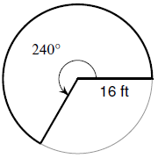
Arc Length and Area of a Sector
Find each requested measurement.

1. central angle = 67°, radius = 3 m 2. Find arc length.
Find area of sector.

3. arc length = 17 in, radius = 4 in 4. area of sector = 34 cm², central angle = 105°
Find central angle. Find radius.

Equation of a Circle
Determine the center and radius of each circle.

5. $(x-5)^{2}+(y+6)^{2}=9$ 6. $${(x-9)}^{2}+y^{2}=60$$

7. $x^{2}+y^{2}+8x-4y+11=0$ 8. $$x^{2}+y^{2}+24x+10y+160=0$$

Inscribed Angles
Solve for each indicated measurement.
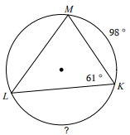  9. | 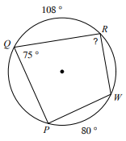  10. | 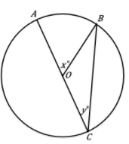  11.
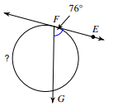  12. | 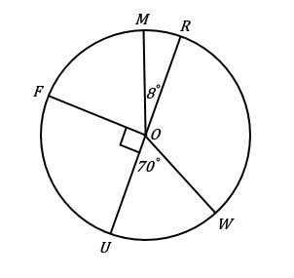  13. Find arc MRF.

Chords
Solve for each indicated measurement.
14. Find length of AB  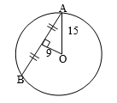 | 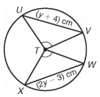  15. | 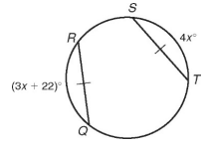  16.
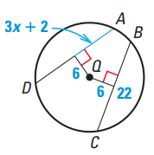  17. | 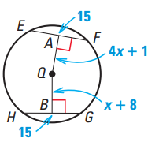  18.

Tangents
Solve for the variable.
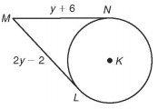  19. | 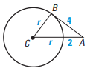  20. | 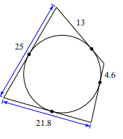  21. Find perimeter.

Angles Formed By Secants, Tangents, and Chords
Solve for x.
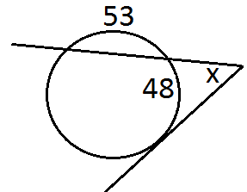  22. | 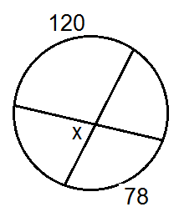  23. | 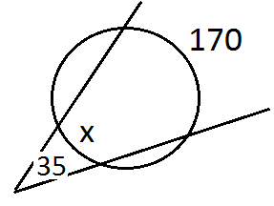  24.

Lengths Formed By Secants, Tangents, and Chords
Solve for x.
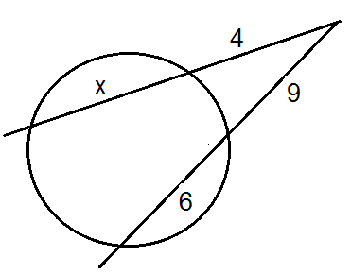  25. | 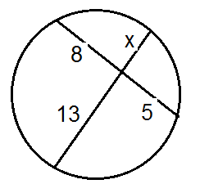  26. | 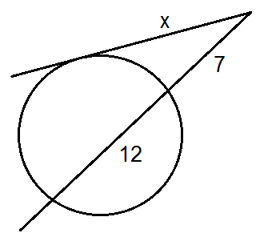  27.
Fun with Factoring!!
Factor.

28. $4x^{2}-9$ 29. $-6g^{7}+7g^{4}$ 30. $w^{2}-5w+6$

31. $5a^{3}-10a^{2}-15a$ 32. $3x+2$ 33. $20x^{2}+13x+2$

