6.7 - Lengths with Secants, Tangents, and Chords
Determine the value of x.

1. | 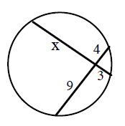 | 2. | 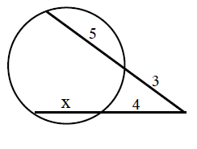 | 3. | 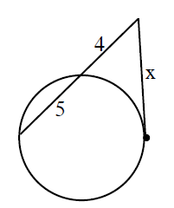
4. | 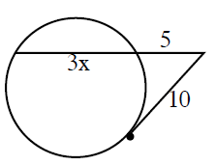 | 5. | 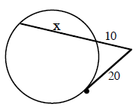 | 6. | 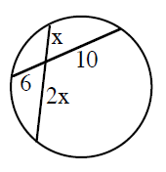
7. | 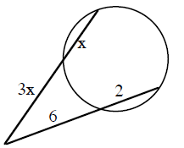 | 8. | 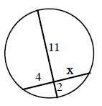 | 9. | 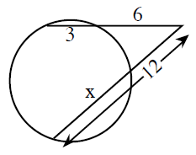

Fun with Factoring!

10. $3x^{2}+26x+16$ 11. $6x+12$ 12. $4x^{2}-15$

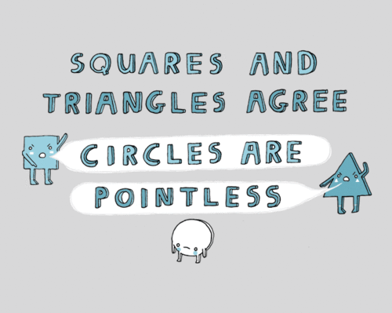
Name ______________________________________________

Math 3 Unit 6: Circles

 | April 10  - Arc length and area of sector  HW: worksheet 6.1 | April 11  - Equation of a circle  HW: worksheet 6.2 | April 12  - Inscribed angles  HW: worksheet 6.3 | April 13  - Chords  HW: worksheet 6.4
April 16  - QUIZ!!  - Tangents  HW: worksheet 6.5 | April 17  - Angles formed by secants, tangents, and chords  HW: worksheet 6.6 | April 18  - Lengths formed by secants, tangents, and chords  HW: worksheet 6.7 | April 19  - Review for test  HW: finish review | April 20  - TEST!!!

6.1 - Arc Length and Area of a Sector
Find each requested measurement.

1. radius = 7 ft, central angle = 18° 2. radius = 2 in, central angle 240°
Find arc length. Find area of sector.

3. central angles = 130°, arc length = 14 cm 4. area of sector = 116π cm², central angle = 110°
Find radius. Find diameter.

5. arc length = 8π cm, radius = 20 cm 6. radius = 2 m, central angle = 103°
Find central angle. Find arc length.

7. area of sector = 17π cm², central angle = 75° 8. circumference = 4π in, central angle = 87°
Find radius. Find area of sector.

9. Find area of sector. 10. Find arc length.
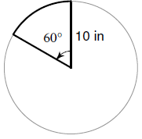
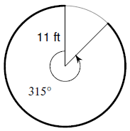

Fun With Factoring!

11. $2x^{3}+6x^{2}$ 12. $x-4$ 13. $3x^{2}+13x-10$

6.6 - Angles Formed By Secants, Tangents, and Chords
Solve for x.
1. | 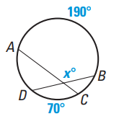 | 2. | 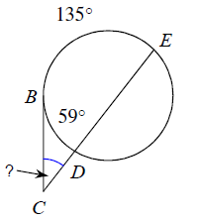 | 3. | 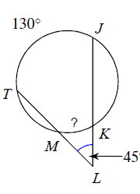
4. | 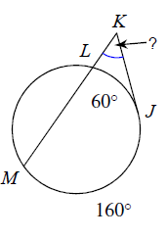 | 5. | 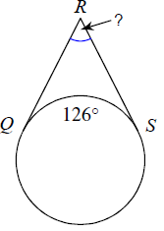 | 6. | 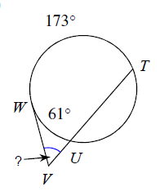
7. | 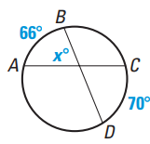 | 8. | 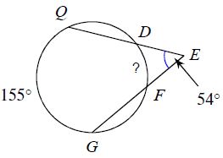 | 9. | 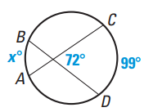

Fun With Factoring!

10. $-3x^{2}-21x-30$ 11. $5x^{2}+45$ 12. $x^{2}+3x+2$

6.5 - Tangents
Determine if line AB is tangent to the circle.
1.  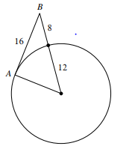 | 2.  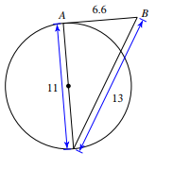 | 3.  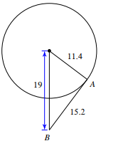

Determine the perimeter of each polygon. Assume lines that appears tangent is tangent.
4.  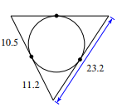 | 5.  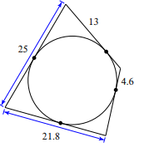 | 6.  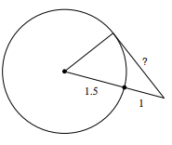

Find the indicated side and angle measures. Assume lines that appears tangent is tangent.
7.  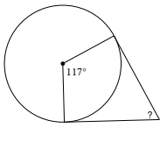 | 8.  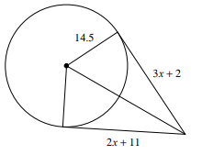 | 9.

Fun with Factoring

10. $25x^{2}-1$ 11. $2x^{3}+2x^{2}-4x$ 12. $2x^{2}-7x-15$

6.2 - Equation of a Circle
For #1 − 4, determine the equation of a circle with the given center and radius.

1. center: $\left(-7, 2\right)$; radius = 5 in 2. center: $\left(-5, -6\right)$; radius = 3 ft

3. center: $\left(0, 7\right)$; radius = $\sqrt{13}$ km 4. center: $\left(1, 14\right)$; radius = 36 cm

5. Find the equation of a circle with center point $\left(-1, 4\right)$and containing the point $\left(5, -4\right)$.

For #6 − 9, determine the equation of a circle in standard form. Then determine the center and radius.

6. $$x^{2}+y^{2}-10x+8y-56=0$$ 7. $x^{2}+y^{2}-14x+4y+35=0$

8. $$x^{2}+y^{2}-2x+6y-3=0$$ 9. $$x^{2}+y^{2}+12x-45=0$$

Fun with Factoring

10. $6x^{2}-5x-25$ 11. $4x^{2}-81$ 12. $3x-5$

6.3 - Inscribed Angles
Find the value of each variable. For each circle, the dot represents the center.

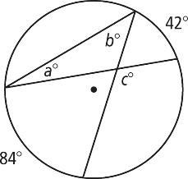  1. | 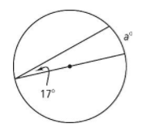  2. | 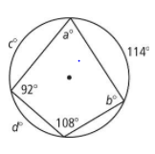  3.
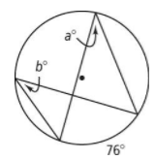  4. | 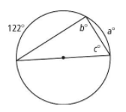  5. | 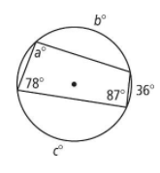  6.
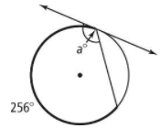  7. | 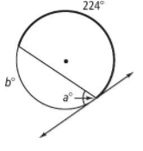  8. | 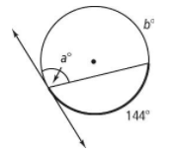  9.

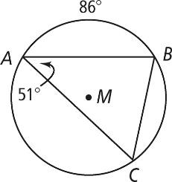
Find each indicated measure for M.

10. m∠B 11. m∠C

12. $m\hat{BC}$ 13. $m\hat{AC}$

OMG - No Fun with Factoring today!!!! You’re welcome.
6.4 - Chords
Solve for the variable.

1. | 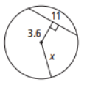 | 2. | 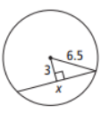 | 3. | 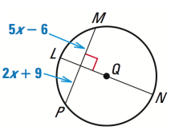
4. | 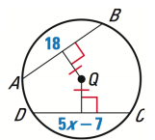 | 5. | 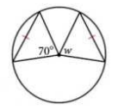 | 6. | 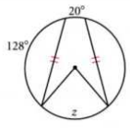
7. | 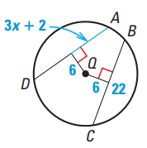 | 8. | 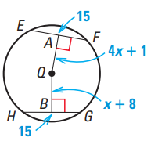

Fun With Factoring!

9. $7x^{2}-28$ 10. $8x^{2}+10x-7$ 11. $3x-9$

