Unit 5 Review - Reasoning with Geometry NAME _________________________________________

Geometric Properties
Solve for x.

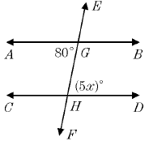
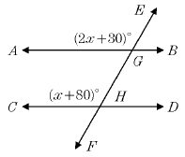
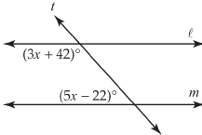
1. 2. 3.

Proofs with Lines and Triangles

4. Given: a || b and c || d  Prove: ∠1 ≅ ∠16  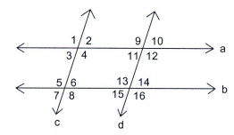 | 5. Given: C is the midpoint of $\underline{BE}$, ∠A ≅ ∠D  Prove: △ABC ≅ △DEC  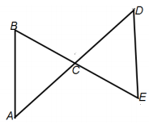
6. Given: $\underline{BC}$ ≅ $\underline{DA}$, $\underline{BC}$ || $\underline{DA}$  Prove: △ABC ≅ △CDA  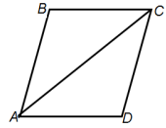 | 7. Given: $\underline{BD} ⊥ \underline{AC}$, $\underline{BA}$ ≅ $\underline{BC}$  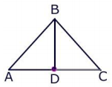  Prove: △BAD ≅ △BCD

Properties of Parallelograms
Solve for x.
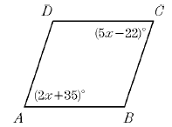
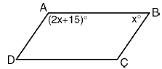
8. 9.

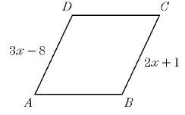
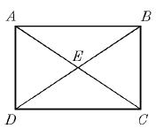
10. 11. $BD=8x+4$ and $BE=22$

Proofs with Parallelograms

12. Given: ABCD is a parallelogram  Prove: △DEA ≅ △BEC  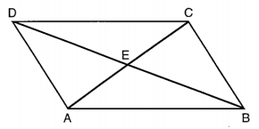  Statement: Reason:  1. 2. $\underline{DA}$ ≅ $\underline{CB}$ 3. ∠DAC ≅ ∠BCA 4. 5. △DEA ≅ △BEC 1. Given 2. 3. 4. Vertical angles 5. | 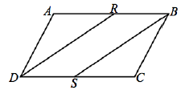  13. Given: ABCD is a parallelogram, $\underline{AR}$ ≅ $\underline{CS}$  Prove: △ARD ≅ △CSB  Statement: Reason:  1. 2. $\underline{AD}≅ \underline{CB}$ 3. ∠DAB ≅ ∠BCD 4. △ARD ≅ △CSB 1. Given 2. 3. 4.
14. Given: ABCD is a parallelogram
Prove: ∠DAC ≅ ∠BCA

Statement: | Reason:
1. ABCD is a parallelogram  2. $\underline{AD}$ ≅ $\underline{BC}$  3.  4.  5. △DAC ≅ △BCA  6. ∠DAC ≅ ∠BCA | 1.  2.  3. Opposite sides of parallelogram are congruent.  4. Reflexive property  5.  6.

Properties of Quadrilaterals
Solve for x (and y, if needed).

15. QTSR is a trapezoid. 16. KMNJ is a rectangle. $KN=3x+14$ and $JM=38$
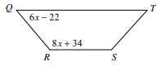
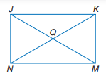

17. ABCD is a rhombus. 18. ABCD is a kite.
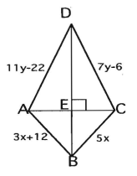
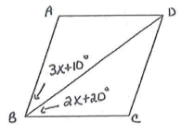

19. Figure is a trapezoid.
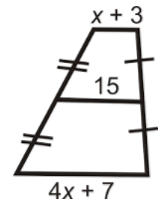

Proofs with Quadrilaterals
20. Given: ABCD is an isosceles trapezoid  Prove: △ADC ≅ △BCD  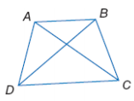  Statement: Reason:  1. 2. ∠ADC ≅ ∠BCD 3. $\underline{DC}$ ≅ $\underline{DC}$ 4. 5. △ADC ≅ △BCD 1. Given 2. 3. 4. Legs of an isosceles trapezoid are congruent 5. | 21. Given: ABCD is a rectangle  Prove: △ADE ≅ △BCE  Statement: Reason  1. 2. $\underline{AD}$ ≅ $\underline{BC}$ 3. $\underline{AB}$ || $\underline{DC}$ 4. 5. ∠AED ≅ ∠BEC 6. △ADE ≅ △BCE 1. Given 2. 3. 4. Alternate interior angles 5. 6.
22. Given: ABCD is a rhombus  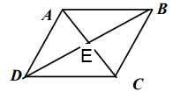  Prove: △DEC ≅ △BEC  Statement: Reason:  1. 2. $\underline{DC}$≅ $\underline{BC}$ 3. $\underline{ED}$ ≅ $\underline{BE}$ 4. 5. △DEC ≅ △BEC 1. Given 2. 3. 4. Diagonals of a rhombus are perpendicular 5. | 23. Given: $\underline{YX}$ ≅ $\underline{WX}$, $\underline{ZX}$ bisects ∠YXW  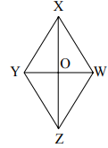  Prove: $\underline{YO}$ ≅ $\underline{WO}$  Statement: Reason  1. $\underline{YX}$ ≅ $\underline{WX}$, $\underline{ZX}$ bisects ∠YXW 2. 3. $\underline{XO}$ ≅ $\underline{XO}$ 4. △YXO ≅ △WXO 5. $\underline{YO}$ ≅ $\underline{WO}$ 1. 2. Definition of bisect 3. 4. 5.

