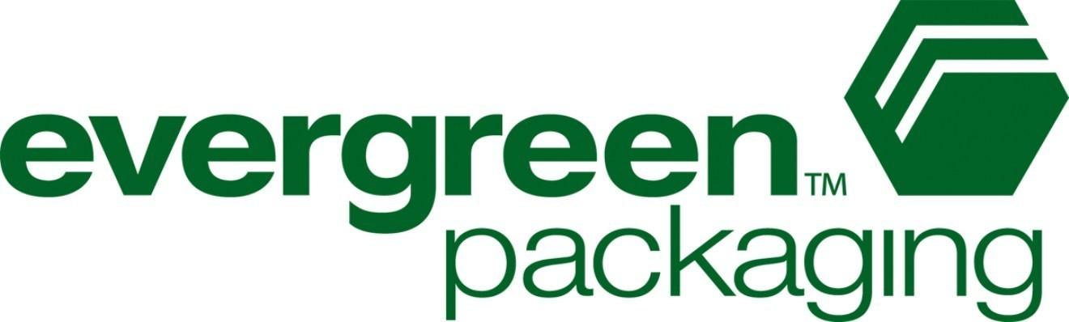
Evergreen Packaging in Raleigh makes cartons for school milk. They have just been told by the milk distributor that they want to change the volume of milk that is in each carton from. They want to take this opportunity to try a new shape for their cartons to try and bring attention to their product. You are tasked with designing a new carton for the milk.

Your team has several cartons to choose from which must be made from one cut of paper (a net) and then folded into the carton. You will have to provide the following specifications with your carton design:

1) The volume and surface area of your carton.
2) The layout of the stamp that will cut the shapes out of the paper with all dimensions (flat net)
3) A finished example of what the carton will look like folded and finished (folded up net)
4) All calculations used in coming up with your design.

You will be presenting this information and your prototype carton to representatives of Evergreen packaging. This will be a formal, business presentation.

Important Dates:
Feb 21 – Assign nets to students and students start working on finding measurements in class
Feb 22 – Work on individual part at home
Feb 23 – Checkpoint 1 - Individual Measurements Due
Feb 26 – Discuss findings and decide on shape – assign next task
Feb 27 – Work on design and research at home
Feb 28 – Checkpoint 2 -- Students Work on Project Presentation Created and Peer Edited
Mar 1 – Test
Mar 2 – Project presentations

Got Milk? Group Project Document 1 - Due February 23

Group Member 1: ______________________________

Group Member 2: ______________________________

Group Member 3: ______________________________

Each member of the group will need to complete a column of the table below individually by the first checkpoint.

To individually complete your section of this table you need to...
- Folded one net into the carton
- Find and label all measurements and dimensions on the flat net. Don’t forget to include units of measure.
- Once you have measurements, you will need to fill out the table below to find the surface area and volume for your carton.

Group Member 1 Group Member 2 Group Member 3
What shape(s) is your carton?
Find the area of the base.
Find the area of the lateral faces.
Find the height of the carton.
Find the total volume of your container. List all of the dimensions needed to find the volume.
Find the surface area.
Find area of any tabs that are part of your net and will be used for glueing the carton together.

Got Milk? Project Document 2 - Due February 28

Group Member 1: ______________________________

Group Member 2: ______________________________

Group Member 3: ______________________________

You will need to complete all of these tasks as a group to prepare for your final presentation.

- At checkpoint 2, you will all need to compare your designs and decide as a group which design you like best. You will want to consider all factors such as best volume, least paper used, overall aesthetic and marketability.

- You will need to design what the images on the sides of your carton will look like. Remember there is a lot of required information that you will have to include, so make sure you do your research. Be careful with colors. When printing, each different color costs costs more money! Get creative but keep in mind the cost!

- You need to make a prototype of your carton that is folded, glued, and has the design printed on it. A final product.

- You will need to include your final net with all dimensions labeled accurately to present with your prototype.

- You need to create a presentation to present your final prototype. It needs to include your net design, proof of its volume and surface area and the design for the carton. You are pitching your design so you really want to sell it and explain why yours is the best.

