Day 1: Solving by factoring
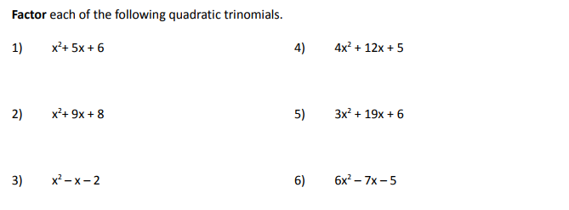

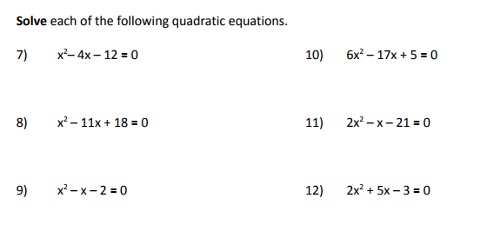
Day 2: Solve by quadratic formula

Write the quadratic formula here: _________________________________________

Identify $a,b,$and $c$ in the following quadratic equations. Then, use the quadratic formula to solve the quadratics.
(Hint: Be sure each equation is written in standard form!)
1. $2x^{2}+4x-8=0$ 2. $x^{2}-7x=0$

3. $x^{2}=8x-5$ 4. $10x+3=4x^{2}$

Find the solutions to each equation using the quadratic formula. Show your work!

5. $x^{2}-8x+2=0$ 6. $0={-3x^{2}+6x+3}^{}$

7. $2x^{2}+4x=5$ 8. $1-4x {=x}^{2}$

Day 3: Solving by Square Root Method

Part 1: Simplify the radicals
1. $\sqrt{24x^{2}y^{5}z^{3}}$ 2. $\sqrt{72a^{7}bc^{3}}$ 3. $\sqrt{5m^{2}n^{5}}$

4. $\sqrt{20}$ 5.. $\sqrt{108a^{2}b^{3}}$ 6. $\sqrt{121x^{2}y^{4}}$

Part 2: Solving by the Square Root Method
Start by isolating the squared term. Then, solve for x by taking the square root of both sides. Leave all answers in simplified radical form.

4. $y=x^{2}-144$ 5. $y=3x^{2}-24$ 6. $y=$ $-2{(x+1)}^{2}+8$

7. $y=2x^{2}-8$ 8. $-7x^{2}-3 = 9$ 10. $(x-1)^{2} - 3 = 11$

Day 4: Solving Quadratics - all algebraic methods

Solve the following quadratic equations using any appropriate method (factoring, quadratic formula, square root).

1. $y = 2x^{2 }+ 3x - 35$ 2. $y= 4n^{2 }+ 11n + 7$

3. $y = x^{2 }+ 9x - 22$ 4.$y= 3x^{2 }- 5x + 6$

5. $y = x^{2 }+ 6x + 13$ 6. $y= r^{2 }+ 8r$

7. $y = 3x^{2 }+ 5x - 2$ 8. $-x^{2 }-6x = -1$

9. $5r^{2}= 80$ 10. $(x-5)^{2}=6$

Day 5: Imaginary Numbers and Quadratics

Simplify the following radicals.
1. $\sqrt{-25}$ 2. $\sqrt{-32x^{2}y^{4}}$ 3. $\sqrt{-200}$

4. $\sqrt{-36x^{5}}$ 5. $\sqrt{-20xy^{3}z^{2}}$ 7. $\sqrt{-146}$

Solve the following quadratics using the square root method. Express all answers in simplest radical form.

1. $x^{2}+20 =0$ 2. $-3x^{2}- 96 = 0$ 3. $(x+1)^{2}+ 10 = 4$

4. $18x^{2 }-4 = -40$ 5. $-(x+4)^{2} = 4$ 6. $2x^{2} = -56$

Day 6: Solving Quadratics with Imaginary Solutions

Solve each of the following quadratic equations. Express your solutions in simplest a + bi form. Check.

1. $x^{2}+4x +20 = 12x - 5$ 2. $x^{2} = x-1$

3. $2x^{2}-25x +27 = -15x - 10$ 4. $8x^{2}+36x +24 = 12x + 5$

5. $x^{2}+6x +15 = 8x - 2$ 6. $4x^{2}+38x +50 = 10x - 35$

Solve the following quadratics.

1. $25x^{2 }-8 = -7$ 2. $x^{2 }+4x + 5 = 0$

3. ${ x}^{2} - 3x + 10 = 0$ 4. 2$x^{2}-6x + 5 = 0$

Day 7: Quadratic/ Linear Systems

Solve each of the following equations, sketch graphs showing both the linear and quadratic function involved, and label solution points with their coordinates.

- $x+2 =x^{2}+3x - 6$ 2. $-x+2 = x^{2}+x-6$
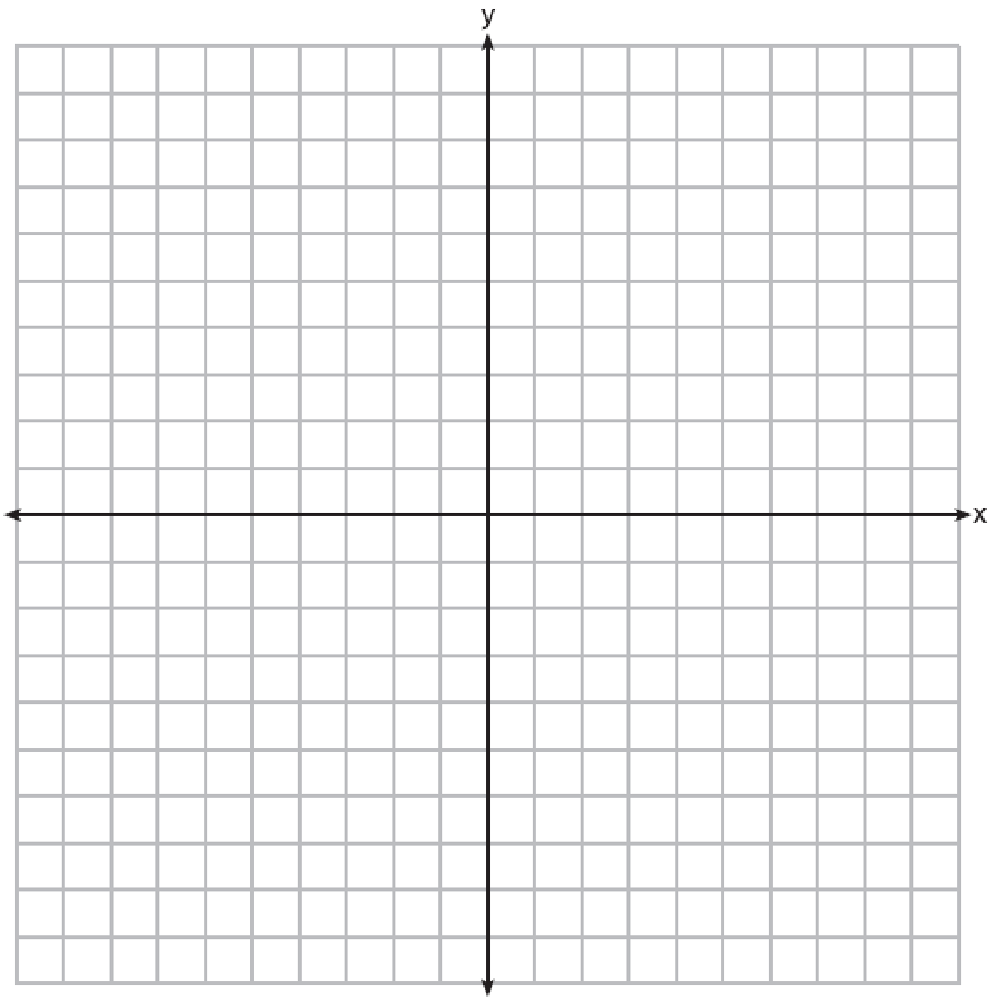

3. $2x + 3 = 4-x^{2}$ 4. $2x^{2 }-x = 3x + 16$

5. Which graph could be used to find the solution to the following system of equations?
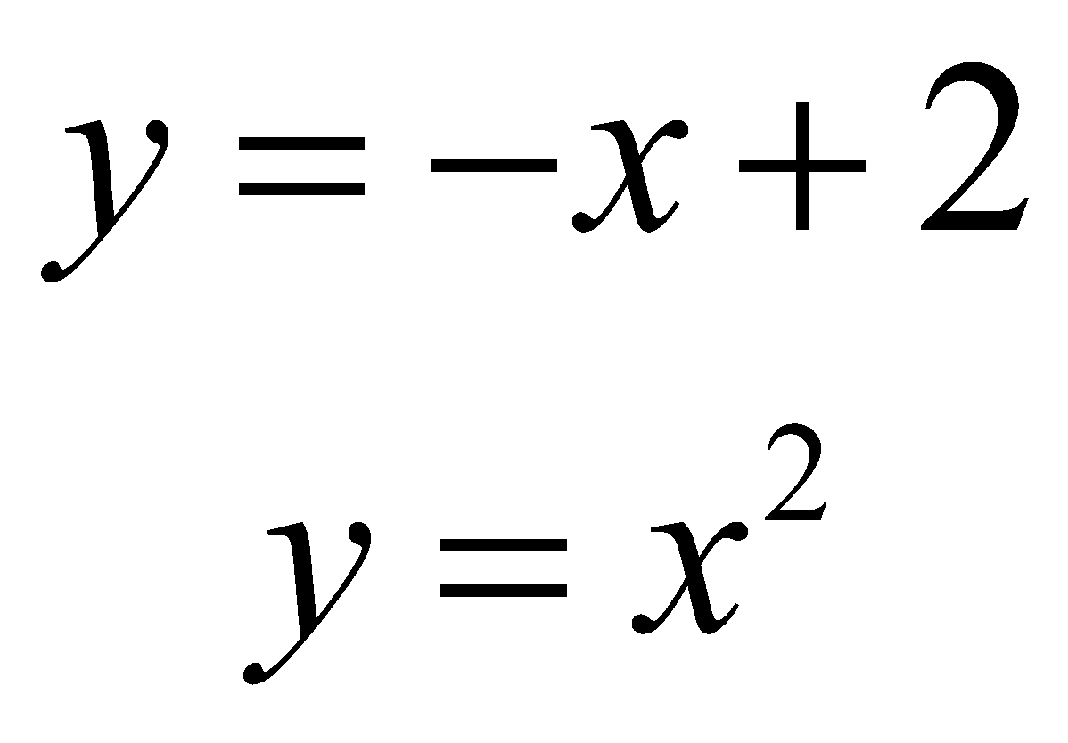 | 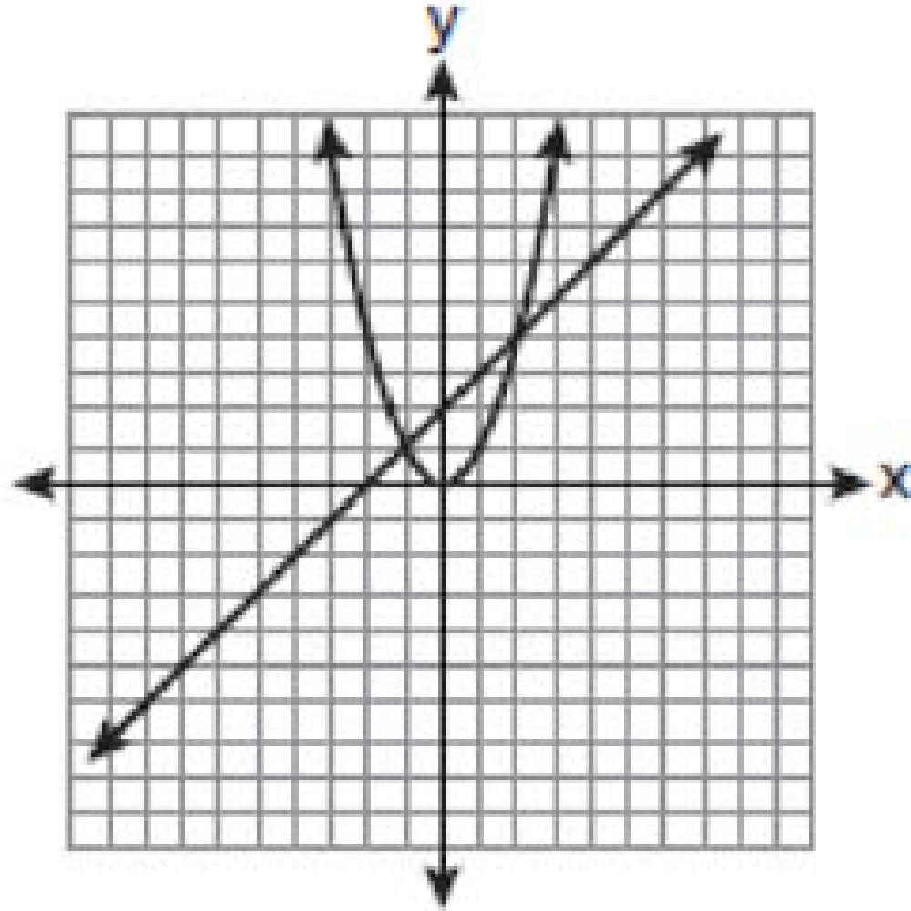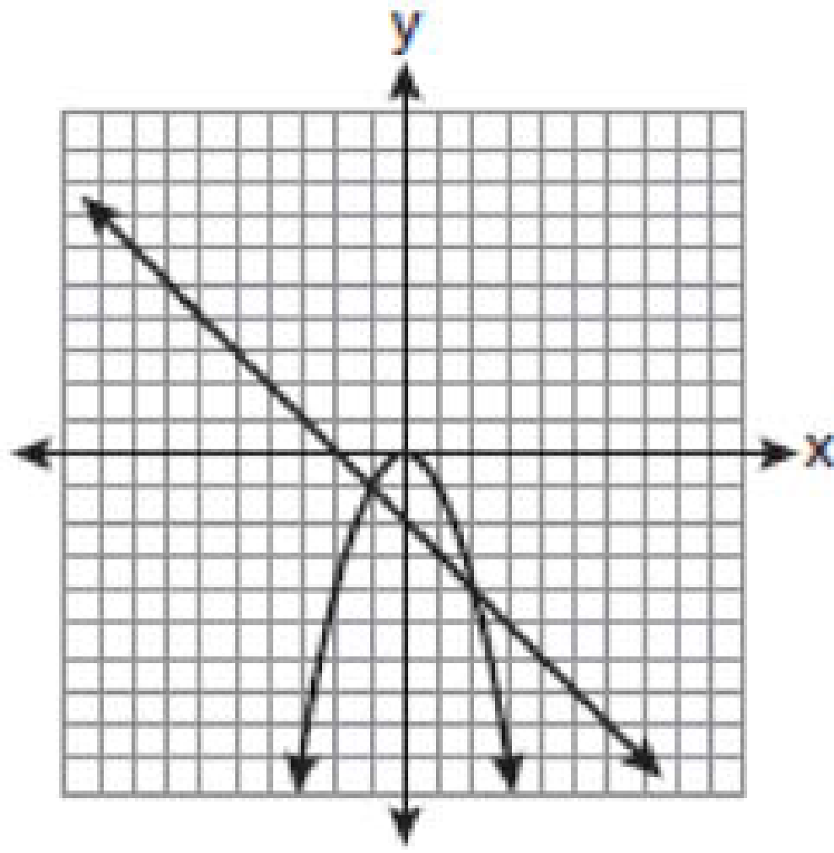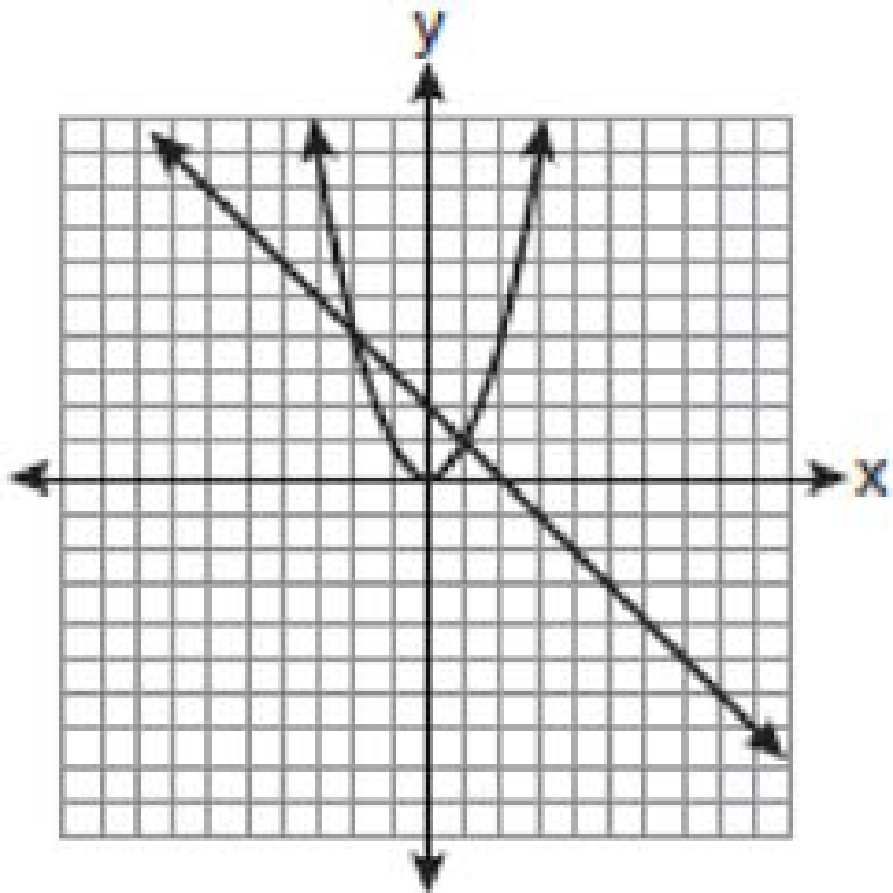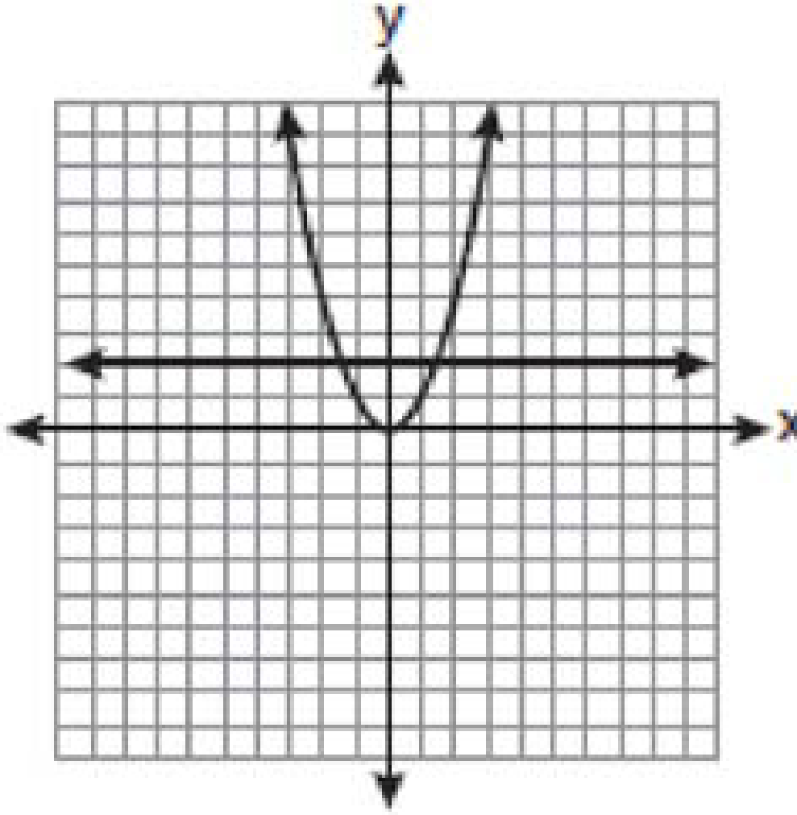  (1) (2) (3) (4)

Day 8: Quadratic Inequalities
Directions: Sketch each inequality on the left. Then, examine the graph to determine the solution. Match the inequality to its solution on the right.
