3. tan(A) = ________ 5. sin(E) = ________

5
A
B
C
12 13

5
F
E
G
3

Solve for the value of the variable(s). Show your work on a separate sheet of paper.
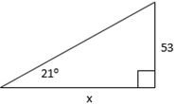
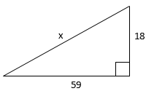
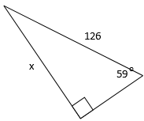
6. x = ___________ 7. x = ___________ 8. x = ___________

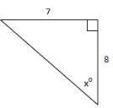
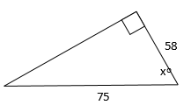
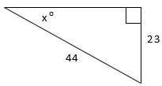
9. x = ___________ 10. x = ___________ 11. x = ___________

12. x = ___________, y = ___________, 13. Perimeter (to the nearest whole) = ___________
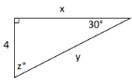
Perimeter (to the nearest whole) = ___________

A
B
C
24
74
o

40

15
16
y
x
o

14. x = ___________, 15. x = ___________,

A
B
C
D
28
y
20
12
x
o
y = ___________ y = ___________

