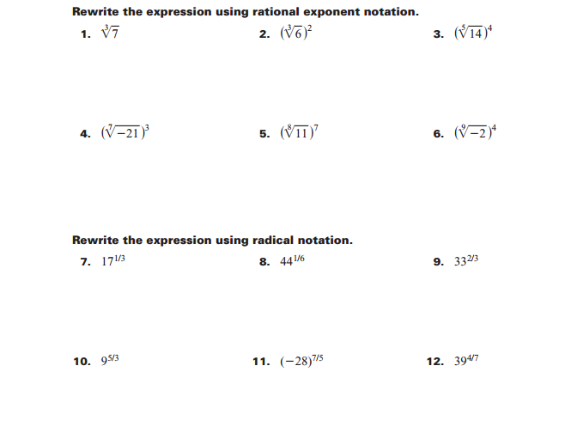
Day 1 Homework: Rational Exponents
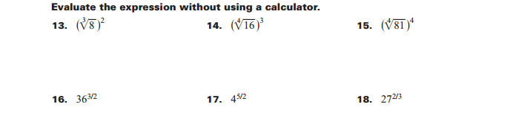
Day 2 Homework: Solving Radical Equations
Solve the following for x using the notes from the video! You may work with your peers. Be sure to check for extraneous solutions! Show all your work on a separate sheet of paper.

- 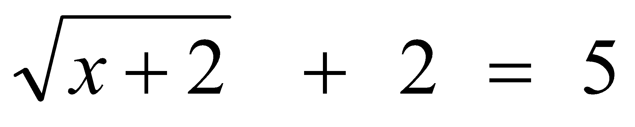

- 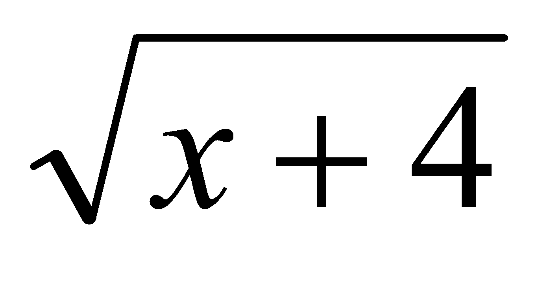 + 2 = x

- 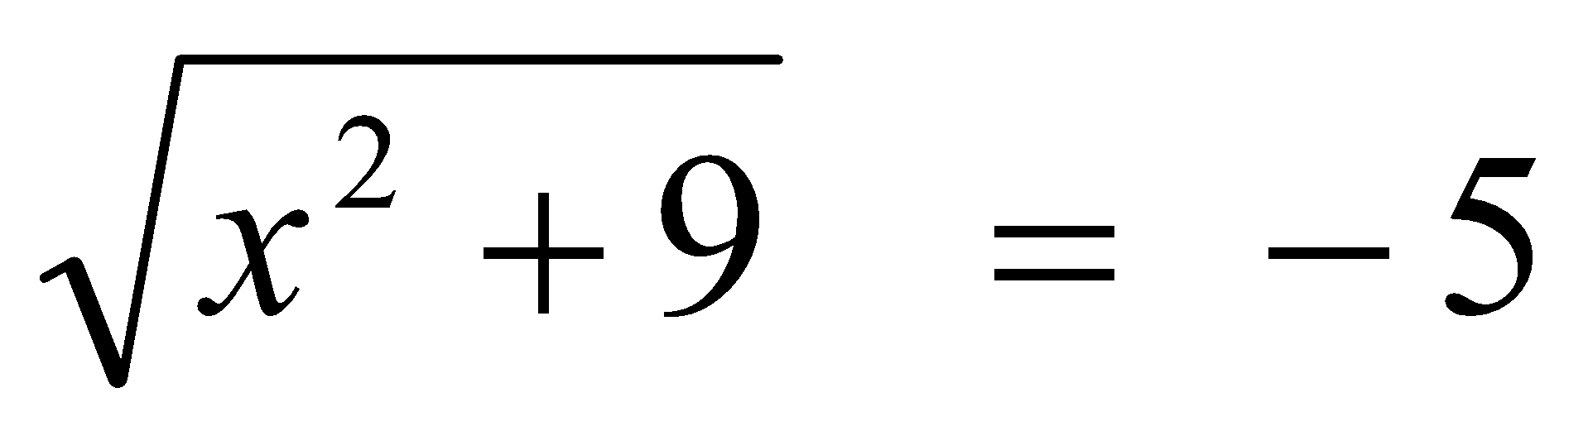

- 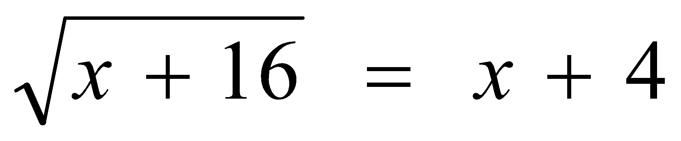

- 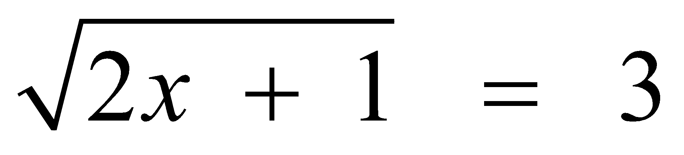

- 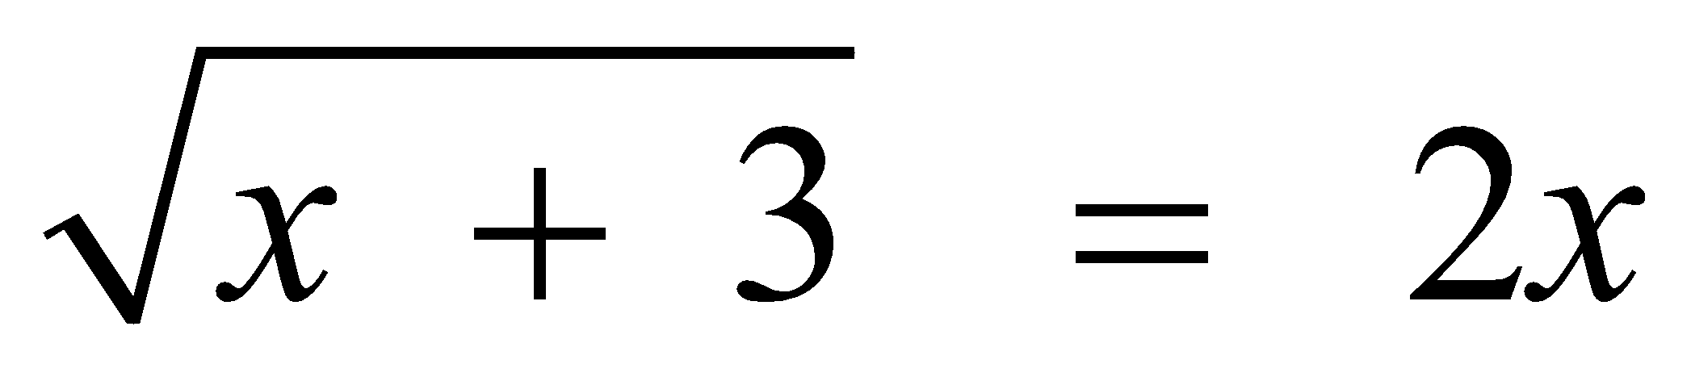

- 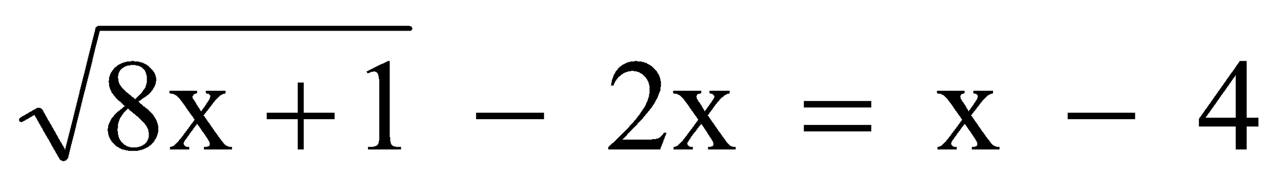

- 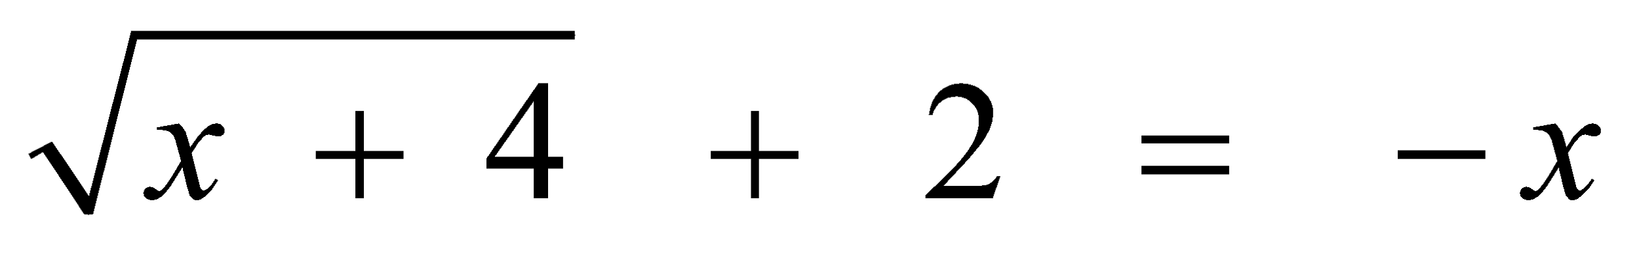

- 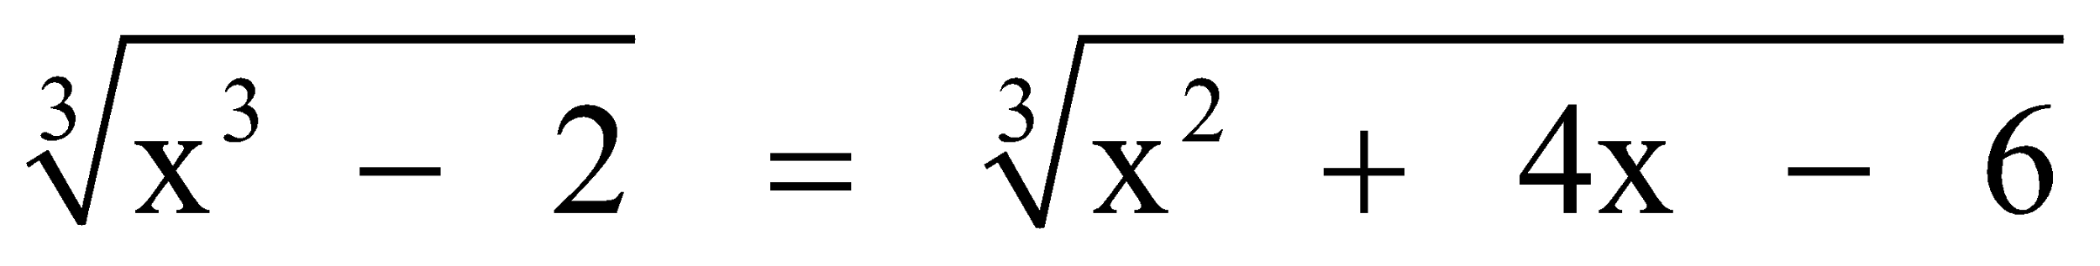

- 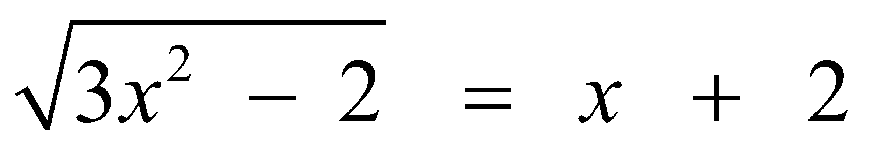

- 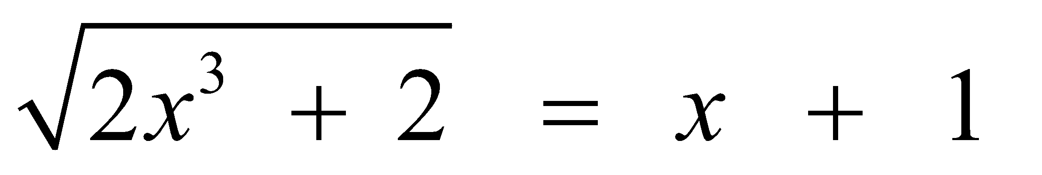

13. The number of people, y, involved in recycling in a community is modeled by the function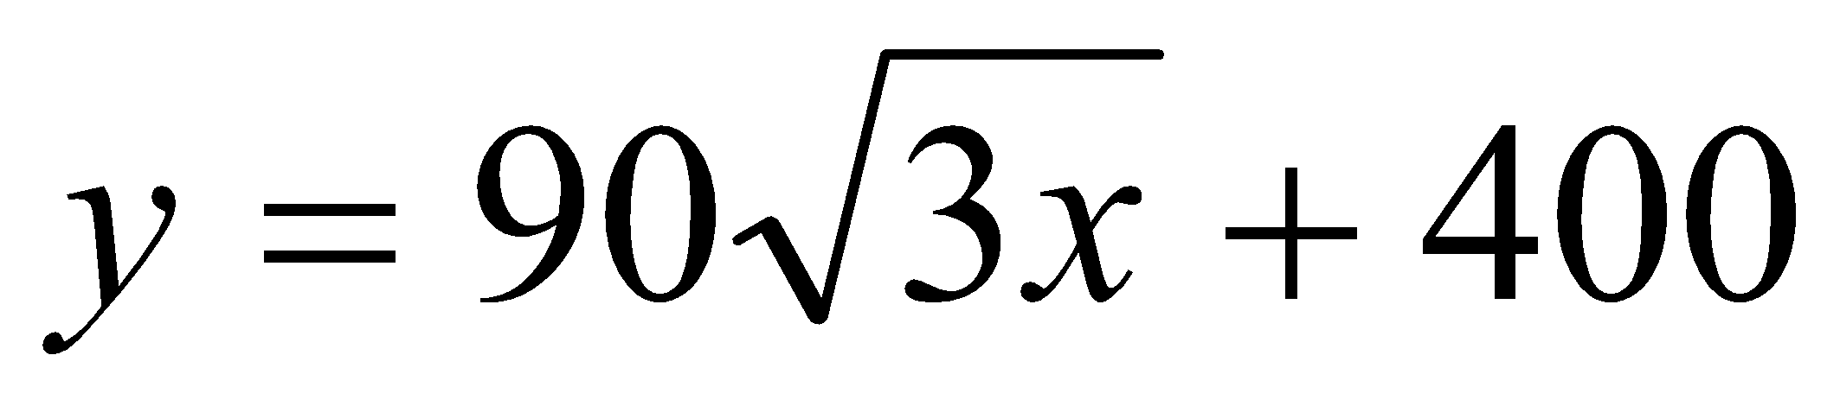, where x is the number of months the recycling plant has been open.

- Find the number of people involved in recycling exactly 3 months after the plant opened.

- After how many months will 940 people be involved in recycling?

Day 3 Homework: Graphing Radical Functions

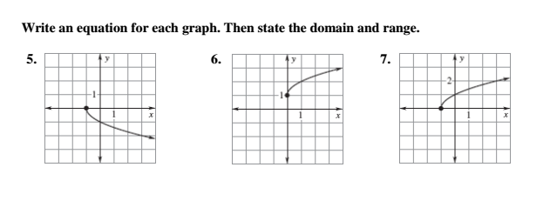
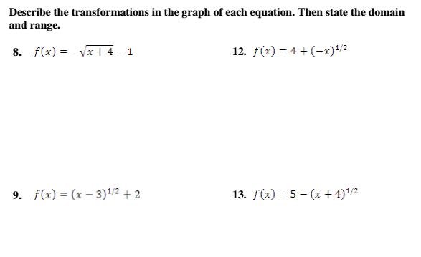

Day 4 Homework: Applications of Radical Functions
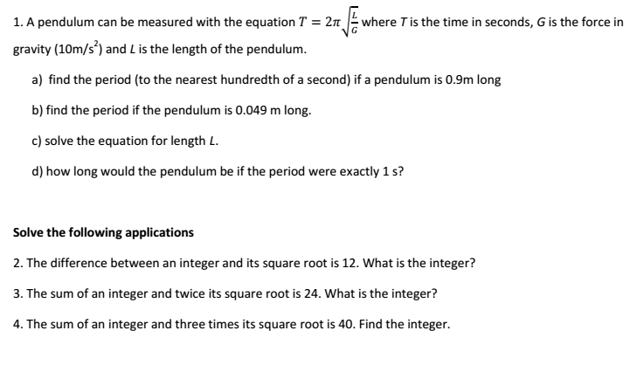
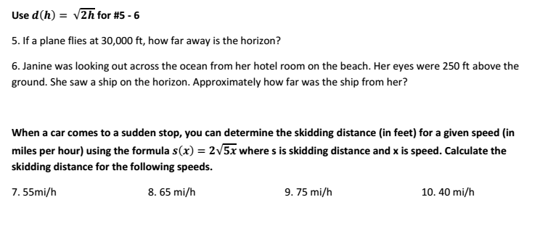
Day 5 Homework: Direct and Inverse Variation
Find the Missing Variable:

- y varies directly with x. If y = -4 when x = 2, find y when x = -6.

- y varies inversely with x. If y = 40 when x = 16, find x when y = -5.

- y varies inversely with x. If y = 7 when x = -4, find y when x = 5.

- y varies directly with x. If y = 15 when x = -18, find y when x = 1.6.

Classify the following as: a) Direct b) Inverse c) Neither

5) m = -5p 6) c = 3v 7) r =

8) n = ½ f 9) d = 4t 10) z = 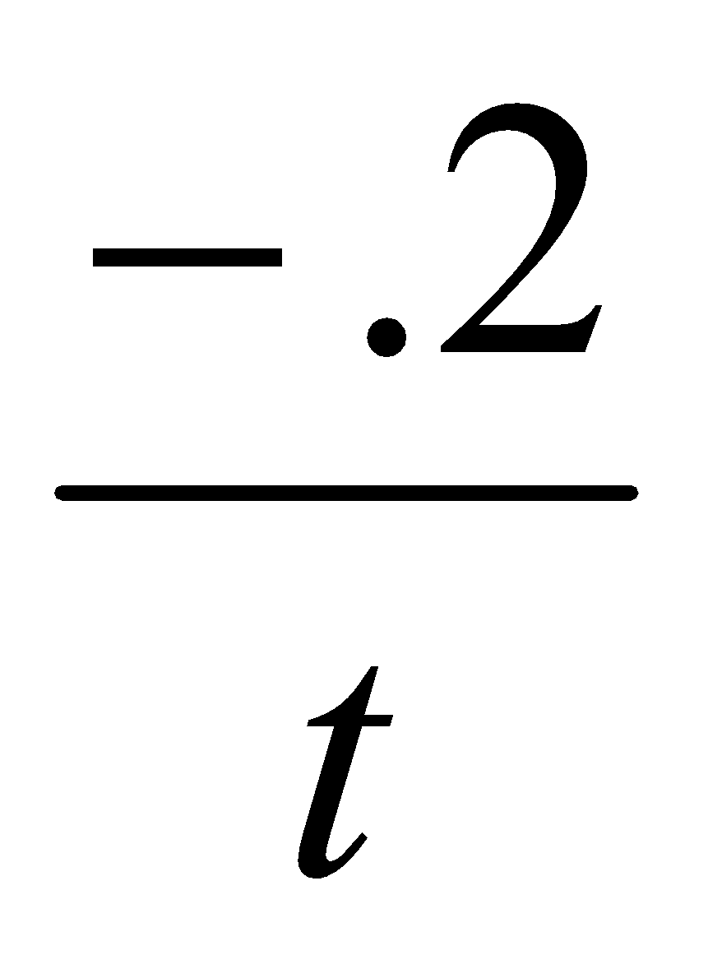

What is the constant of variation for the following?

11) d = 4t 12) z = 13) n = ½ f 14) r =

Answer the following questions.

18) If x and y vary directly, as x decreases, what happens to the value of y?

19) If x and y vary inversely, as y increases, what happens to the value of x?

Answer the following questions:

20) The electric current I, is amperes, in a circuit varies directly as the voltage V. When 12 volts are applied, the current is 4 amperes. What is the current when 18 volts are applied?

21) The volume V of gas varies inversely to the pressure P. The volume of a gas is 200 cm³ under pressure of 32 kg/cm². What will be its volume under pressure of 40 kg/cm²?

Day 6 Homework: Solving Rational Functions
Determine whether the given x-value is a solution of the equation:
1. 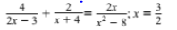 2. 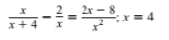

Solve the rational equations by cross multiplying. Be sure to check for extraneous solutions!
3. 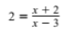 4. 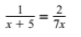 5. 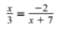

6. 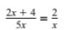 7. 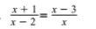 8. 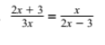

Day 7 Homework: Graphing Rational Functions
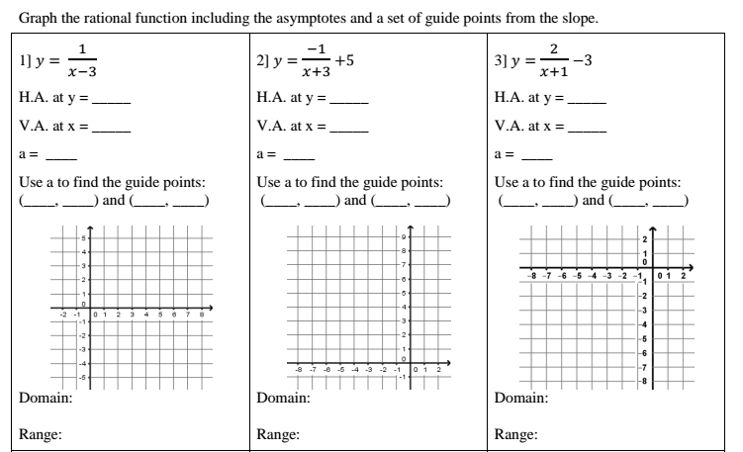
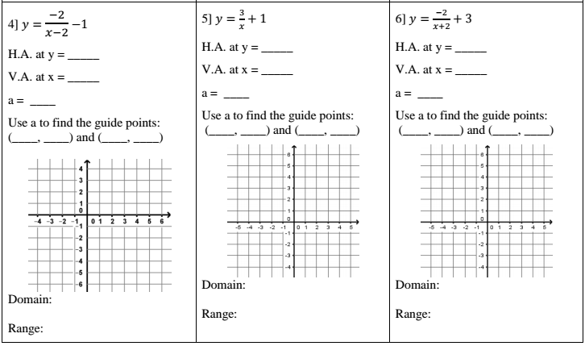
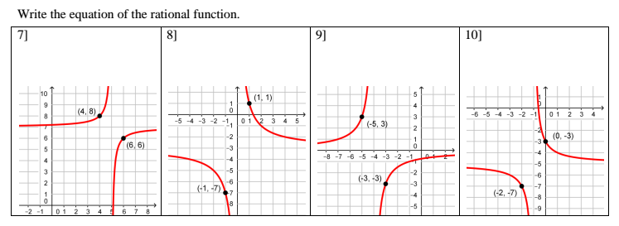

Day 8: Graphing and Systems
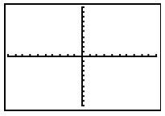
Solve each system. Then represent the solution on a graph. Label any key points.
- 

 