Math 2 Makin’ Money

After all your hard work learning this quadratic stuff, it’s time to earn some cash. Each problem below is worth a certain amount of money. You may select any problems to do, but you must meet two requirements:
1: Do at least one problem from each level.
2: You must make at least $20.00 worth of problems.

Please clearly show all work on a scratch sheet of paper. Number each problem you choose to do and write the dollar value of the problem beside it. When you have completed $20.00 worth of problems, show the boss to redeem your paycheck.

Level 1: $1.00
1a) Identify the Domain and Range from the graph of the function below.
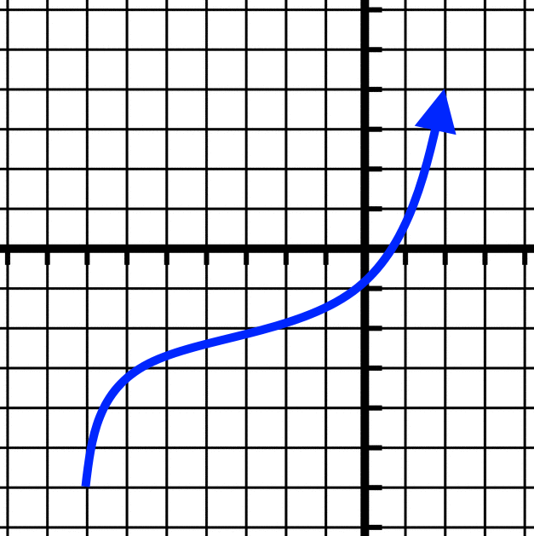

1d) Write the equation for the parabola shown in the graph below in vertex form.
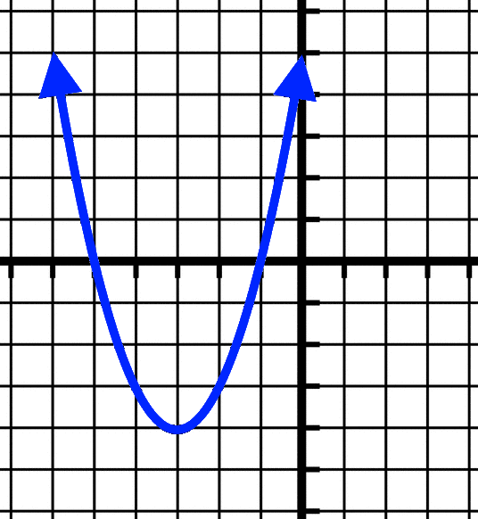

1g) Factor the following quadratic expression:
$$y=x^{2}+5x+6$$

1b) Identify the Domain and Range from the graph of the function below.
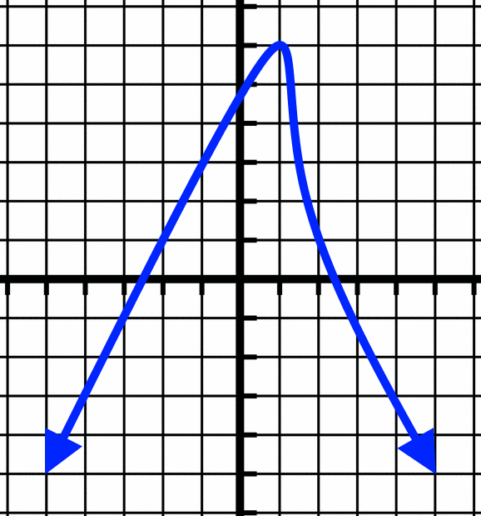

1e) What are the coordinates of the vertex given by the equation:
$$y=-7{(x-3)}^{2}+8$$

1h) Write an equation of a quadratic in vertex form that has both a reflection and a shift to the right.

1c) Write the equation for the parabola shown in the graph below in factored form.

1f) List the transformations given by the equation:
$$y=\frac{1}{4}F(-x)-3$$

1i) Write an equation of a quadratic in vertex form that has vertical stretch by a factor of 3 and a shift up 5.

Level 2: $3.00
2a) Write the equation for the parabola shown in the graph below in vertex form.
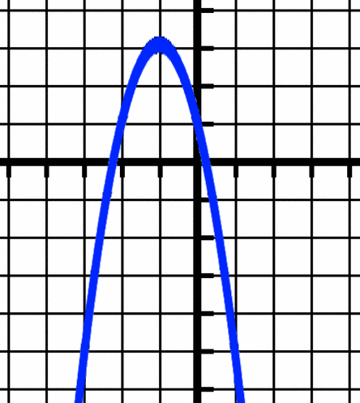

2d) Convert the following quadratic equation from vertex form into standard form:
$$y={(x+3)}^{2}-10$$

2b) Factor the following quadratic expression:
$$y=20x^{2}-3x-2$$

2e) Convert the following quadratic equation from factored form into standard form:
$$y=(x-5)(x+6)$$

2c) Factor the following quadratic expression:
$$y=x^{2}-64$$

2f) There is a parabola with a vertex at $$(-2,5)$$ and root at $$(3,0)$$. Where is the other root? Explain or show a picture.

Level 3: $5.00
3a) Graph and give a table of characteristic points for a quadratic that has been reflected over the $$x$$-axis, vertically stretched by factor of 2, and shifted up 6.

3b) Write the standard form equation for a parabola that crosses the $$x$$-axis at $$-2$$ and $$7$$.

3c) Convert the following quadratic equation from standard form into factored form:
$$y=6x^{2}-39x+63$$

