Math 2 Unit 2A - Unit Review Name: _____________________

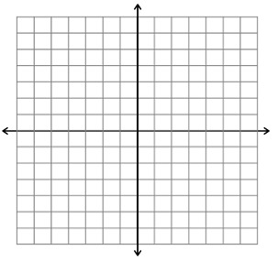
For 1-3, graph the given transformed quadratic function using a table of characteristic points.
1. $y=\frac{1}{2}(x+4)^{2}$

x | y

2. $y=-(x-3)^{2}-2$

x | y
3. $y=-2(x+7)^{2}$

x | y
For 4-5, convert each quadratic equation in vertex form to factored form. Be sure to swing by standard form on your way!
4. $y=2(x-3)^{2}-8$

Standard Form:

Factored Form:

5. $y=-(x+2)^{2}+1$

Standard Form:

Factored Form:

For 6-9, factor the quadratic expression.
6. $x^{2}-8x-33$ 7. $15x^{2}+2x-8$

8. $14x^{2}-49x+21$ 9. $2x^{2}+26x$

