Name: _______________________________
Applications of the Pythagorean Theorem
(1) Google Fiber needs to lay new cable in downtown Raleigh. Unfortunately, workers are unsure of the length of cable needed to complete the project. Your job is to calculate the amount of cable necessary and then provide a price for the cable. The cable costs $14.99 per foot.
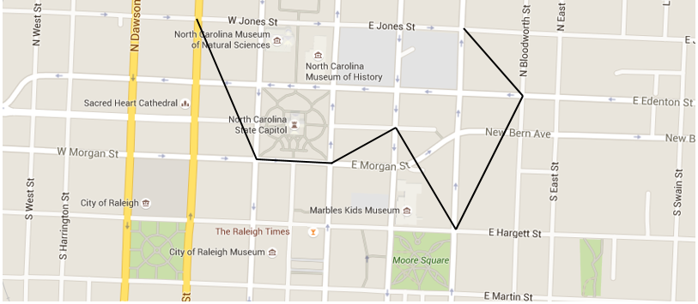

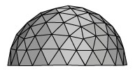
(2) Google Fiber would also like to build a modern headquarters building in downtown Raleigh. Their design includes a dome-shaped roof made of steel tiles. They know they will use 500 triangular tiles measuring ten feet on each side. However, the project planners are unsure of how much this design would cost. Your second job is to determine the price of the tiles if they cost $15 per square foot.

