1. a) How do you know if an equation b) Circle all the equations below that will graph
will graph as a parabola? as a parabola.

$y=(x+4)(2x-1)$ $y=6x+8$

$y=x^{4}-x^{2}$ $y=x^{2}-3x+9$

2. Rewrite the following quadratic equation 3. Multiply: $(3x-4)^{2}$
in standard form: $y=(x-6)(2x+3)$

4. Identify the vertex of the function: 5. Identify the roots of the function: $y=(x-8)(x+2)$.
$y={2(x+1)}^{2}+9.$

6. If a parabola opens down and has a vertex 7. A parabola is known to have 2 roots and a vertex
of (3, -5), how many roots will it have? at (3, -5). If one x-intercept is at the at (1, 0),
what are the coordinates of other x-intercept?

8. Write 3 equations (one in each form) 9. Write 3 equations (one in each form)
for the given parabola: for the given parabola:
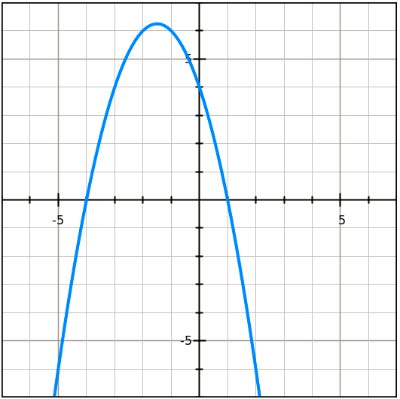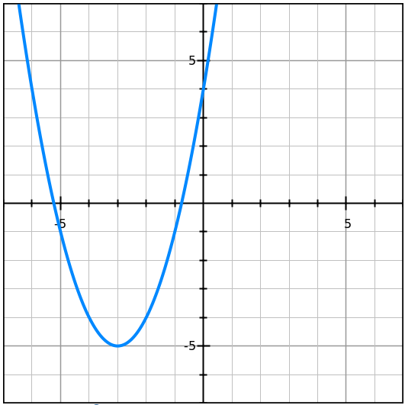

Vertex Form: ______________________ Vertex Form: ______________________

Factored Form: ______________________ Factored Form: ______________________

Standard Form: ______________________ Standard Form: ______________________

10. Factor: $x^{2}-9x-36$ 11. Factor: ${3x}^{2}+15x+12$

12. Factor: ${4x}^{2}+6x-18$ 13. Factor: ${9x}^{2}-25$

Work Space: Here are some spare coordinate grids to work out problems if needed:
